Kush, Jainam, Joshua, Steven

Find and list what will be the roles/functions of Software Development team? Which software tools will they use to perform those functions from requirement analysis to deployment of the product? Briefly describe them. See the following table as an example and continue the table.

**Note:** **for alike software for more than one function, combine the roles together and functions together since description of the software tool will be the same for those roles and functionality.**

|  |  |  |  |
| --- | --- | --- | --- |
| **Roles/ Responsibilities vs Software tools being used by the Software Development Team** | | | |
| Role | Function | Software Tools at least 2 for each type | Description |
| Requirement Analysis,  Finding Objects, classes | Prepare Use cases, class diagram, sequence | (Visual Paradigm), Draw.io etc. |  |
|  |  |  |  |

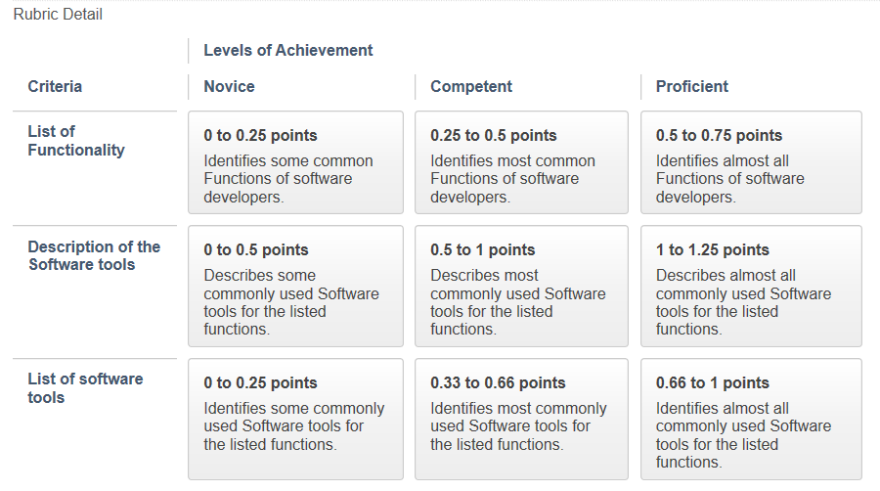

|  |  |  |  |
| --- | --- | --- | --- |
| Role | Function | Tools | Description |
| Project Sponsor | Provide resources | Money | Responsible with working with the project management team to ensure the project is well funded and the rest of the team have all the tool they need |
| Subject matters experts | Business side | Money and marketing | Only worry is the business side of the project. Marketing, funding etc. |
| Product owner | Keeps up with both ends | Power point, product canvas, Prezi | Deciding what goes on in the company; what to market, what to add to the application in terms of features, etc. |
| Project manager | Prepares UML diagrams, GANTT charts and flow charts | Management abilities, funds, draw.io , Gantt creator | Recruits staff, makes schedule for development etc. |
| Software Developers | Code the software that they are responsible for | IDE’s such as eclipse, studio visual code, etc. | Responsible for coding the part of the application assigned to them by their supervisors |
| Software testers | Test application for errors | \test studio, Selenium, micro focus unified, etc. | They run the program many times to test for bugs and errors in the program and then compile a report of all errors in the program |
| Technical lead | Communicate the business side to the software side and vice versa | Power point, word, excel, etc. | Translate the requirements of each side to the other |